**LLP Company formation**

**Step1**

**Step 2**

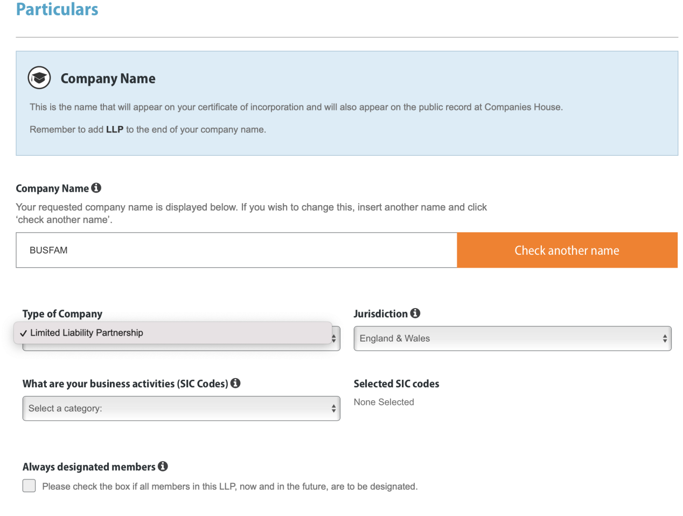



**Next step are same as limited by shares except**

**Appointments page Part1**

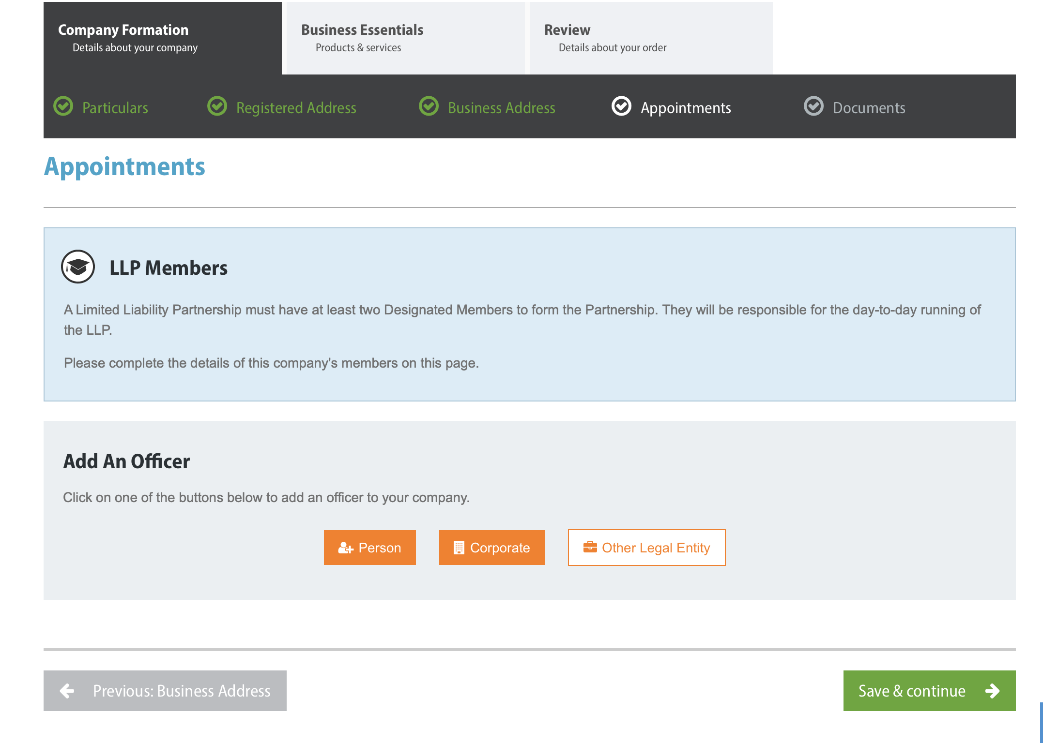

**Appointments page Part2**

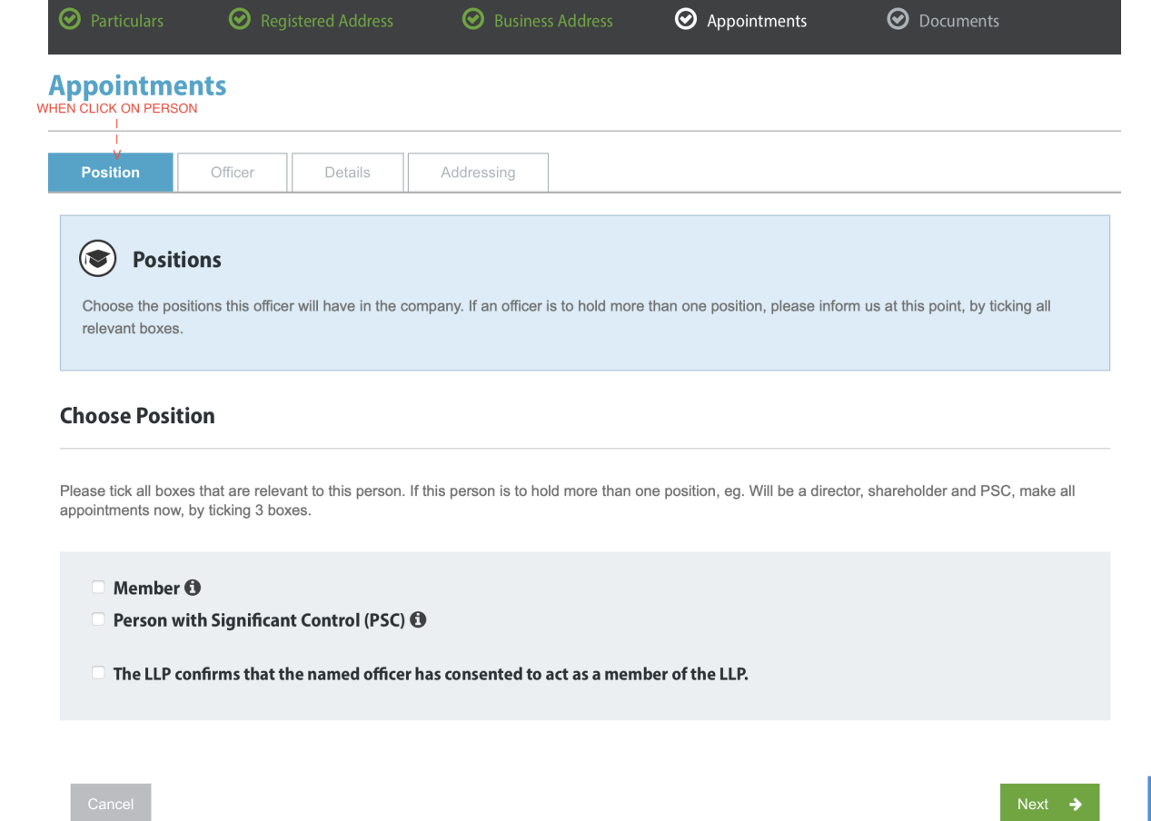

**NEXT STEPS ARE ALL SAME AS LTD BY SHARES EXCEPT**

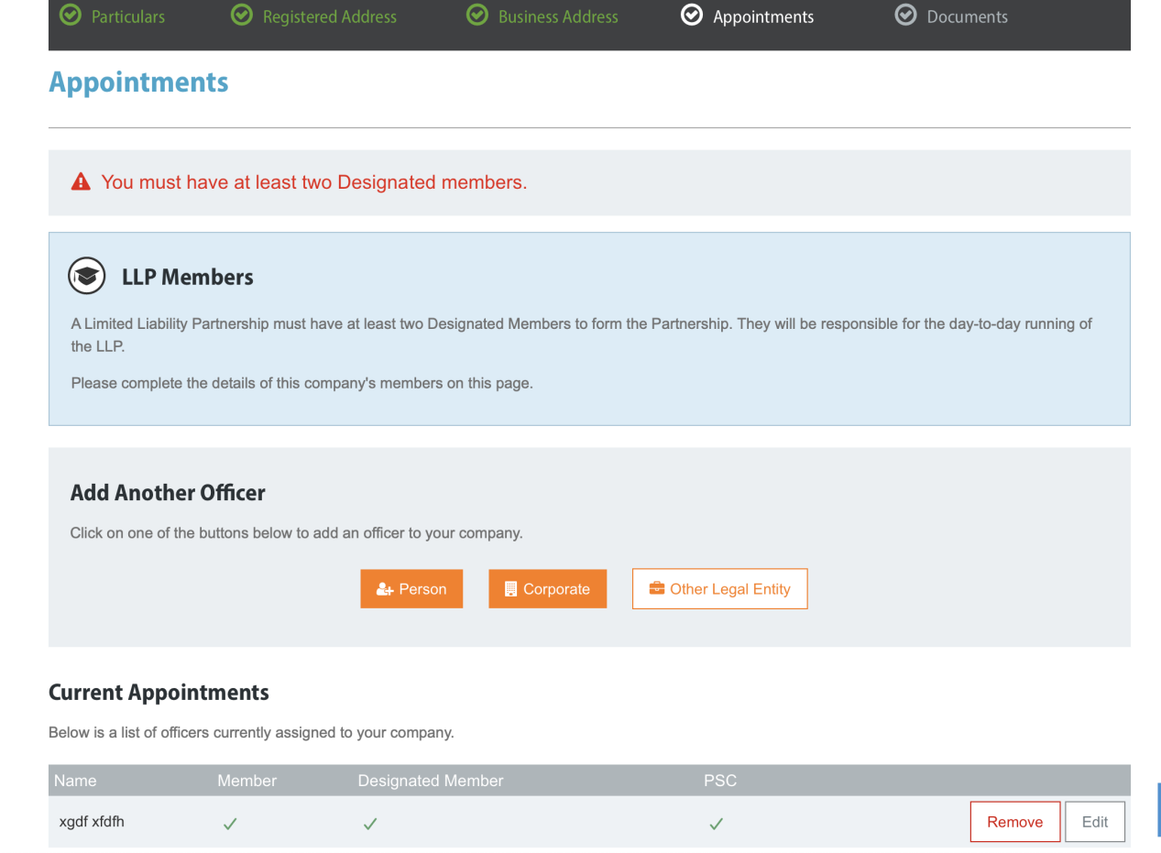

**CAN MOVE FORWARD WITHOUT ADDING ANOTHER MEMBER**

**STEP 3**

**DOCUMENTS SECTIONS REMAINS BLANK**

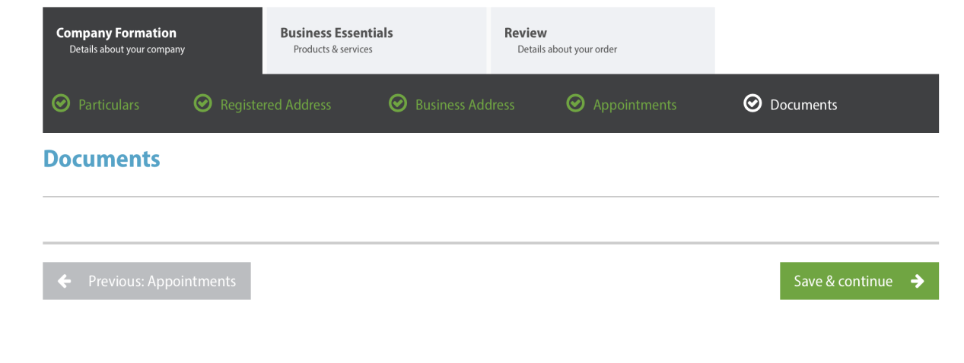

**STEP4**

**REST ALL STEP WORKS SAME AS LIMITED BY SHARES TILL THE FINAL REVIEW PAGE**

**Need Byspoke or generic model as limited by share**

**Psc not mandatory**

**Need Consent for member and designated member**